- First to create a package using ROS 2, I would have to use

**ros2 pkg create --build-type ament_cmake mbot_description**

- Copy everything from the mbot description for week 12 and put it on the folder

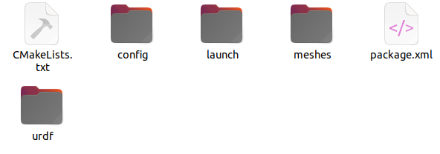

- Check the code to see if we have any differences, or code that need to be changed from ROS 1 to ROS 2

- For the RVIZ file, I think it should work just find

- Launch file structure is about the same between ROS 1 and ROS 2, so I think it should work just fine

Testing if the YAML file works:

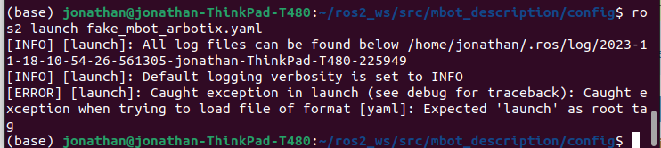

Seems like it does not work properly,

I also got a problem when I tried to run it with xacro:

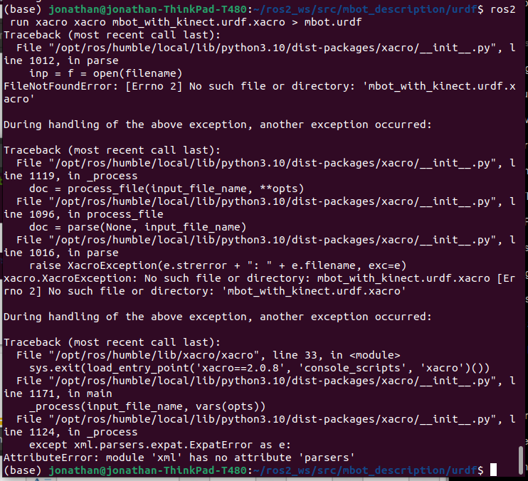

Apparently I used a wrong command, seems like this command works to create mbot.urdf:

**ros2 run xacro xacro mbot_with_kinect.urdf > mbot.urdf**

the pdf file:

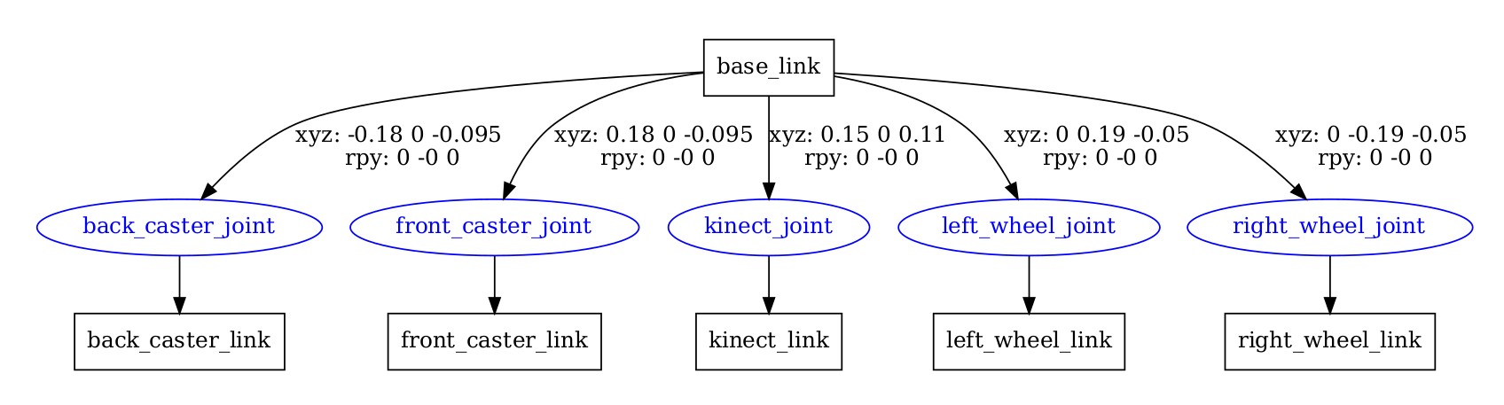

After finishing modifyng the cmake:

cmake_minimum_required(VERSION 3.5)

project(mbot_description)

find_package(ament_cmake REQUIRED)

find_package(rosidl_default_generators REQUIRED)

find_package(urdf REQUIRED)

find_package(xacro REQUIRED)

ament_package()

include_directories(

${urdf_INCLUDE_DIRS}

${xacro_INCLUDE_DIRS}

)

I can build and add the symlink

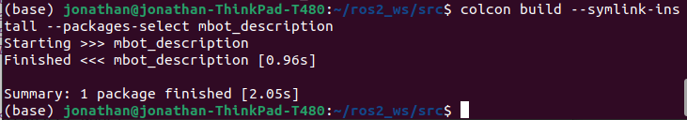

Even after successfully building project, I’m still unable to open or launch the rviz file or even to launch the launch file or anything else. I was able to find every other thing that started with m, but when I tried to do mbot, it does not show it on the list of item that I can launch  
  
So I think this project will not work properly with ROS 2

I tried to install gazebo, I was looking at the online tutorial and got a gazebo running on my computer.

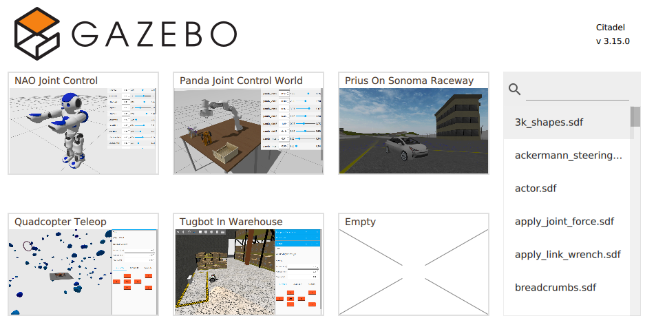

I think at least we could launch the project that has been there already (premade project).

In example, I could run a sample project. In the example below, I will try to move several section of the robots to see the full functionality

http://classic.gazebosim.org/tutorials?cat=tools_utilities&tut=logging_playback

I saw some good link as well that allows us to be able to record or have a log of these gazebo sample projects.

I attached some screenshots of the gazebo project to show how it moves. This example is very interesting since it shows the full functionality of the TF joints (like when you move one section it also move the other ones or affecting it as well).

